Generic writeup

Response: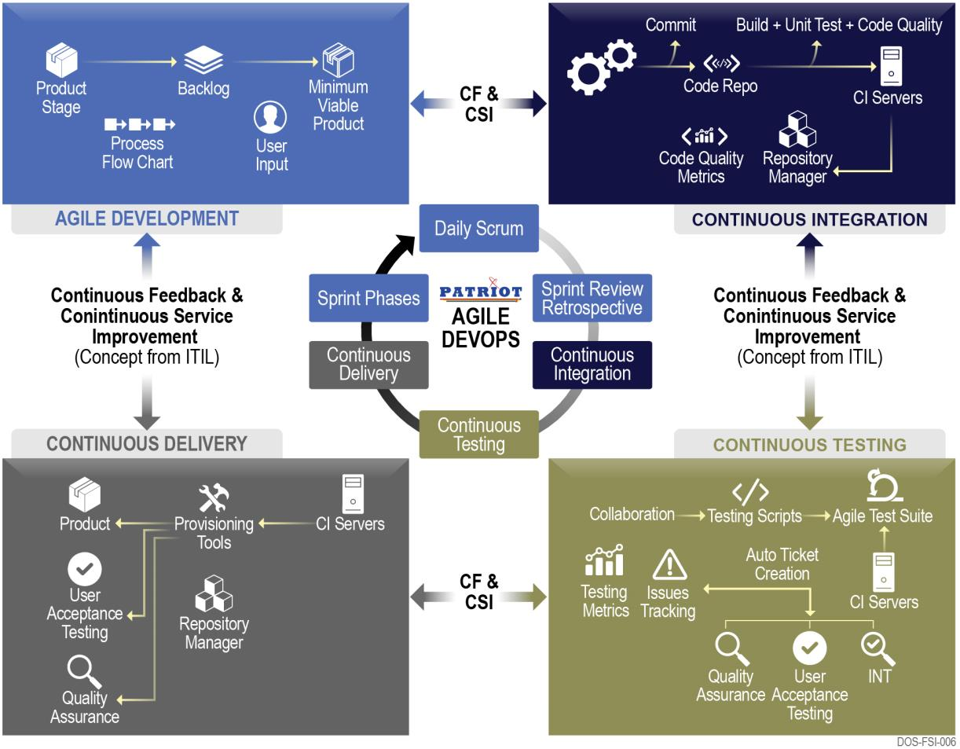

Our technical approach refers to the framework we use to structure, plan, and control the process of developing the current and future OCIO websites and managing the Operation and Maintenance (O&M) phase with implementation of Agile DevSecOps. A variety of such frameworks have evolved over the years, each with its own recognized strengths and weaknesses. We have a hybrid approach to meet today’s government need for faster, cost effective, and secure solutions. We have used several methodologies like Waterfall, Prototyping, Incremental, Spiral, Rapid Application Development, and now Agile/Scrum hybrid to meet our customer needs. Using DevSecOps model to meet the ever-increasing rapid development needs with ease of auto-code deployment and collaboration, we successfully support 25 plus systems using latest in – house and hybrid cloud Software as a Service (SaaS), Platform as a Service (PaaS) and Infrastructure as a Service (IaaS). The technical platforms cover a wide variety and range of technologies and Content Managemernt Systems (CMS) like SalesForce, Drupal(6,7 and 8/9), Joomla, Wordpress, Asp.net, Sharepoint, Stellent, Dreamweaver, PHP, .Net, Java, HTML5, etc. for our government customers including Department of Commerce (DOC), Environment Protection Agency (EPA), General Services Administration (GSA), Department of Education (ED), with new Development, Modernization, Enhancements (DM&E) including O&M phase.

Team Patriot’s DevSecOps solution integrates development and operations into a single- minded entity with common goals: Reliable high-quality software, increased all around Security posture, increased collaboration, faster and easy releases, and improved customer satisfaction. Key Practices developed by Patriot Center of Excellence (COE) have helped organizations/government agencies innovate faster through automating and streamlining the software development and infrastructure management processes. Most of these practices are accomplished with proper tooling.In our Agile DevSecOps approach depicted in **Figure 1**, there are four main practices and series of tools in each practice area: Agile Development, Continuous Integration, Continuous Testing, and Continuous Delivery. These four practices have Continuous Feedback (CF) and Continuous Service Improvements (CSI) with metrics so we can continue to improve and fine tune to get the desired results for our customers. At OCIO, our objective is to apply these COE key practices to build an increased Security bandwidth website that is primarily reliable and easy to navigate, search, and manage along with other attributes.

## Team Patriot Microsoft Azure Agile DevSecOps

* Team Patriot has developed, tested and implemented ready to use Agile DevSecOps environment for Development team on Day 1! of our support for OCIO website hosting service project.

**Continuous Integration:** Continuous integration is a software development practice where developers regularly merge their code changes into a central repository, after which automated builds and tests are run. The key goals of continuous integration are to find and address bugs quicker, improve software quality, and reduce the time it takes to validate and release new software updates. Continuous Integration provides these benefits to OCIO:

* Implement **version control** (Git, Bitbucket, SVN, etc).
* **Write tests** for the critical components in OCIO code base (and treat tests as production code)
* Obtain suitable **continuous integration and delivery service** that will enable OCIO to run those tests on every push to the repository and also deploy builds as needed.

**Continuous Delivery:** Continuous practice where software development code changes are automatically built, tested, and prepared for a release to production. It expands upon **Continuous Integration** by deploying all code changes to a testing environment and/or a production environment after the build stage. When continuous delivery is implemented properly, developers will always have a deployment-ready build artifact that has passed through a standardized test process. The microservices architecture is a design approach to build a single application as a set of small services. Each service runs in its own process and communicates with other services through a well-defined interface using a lightweight mechanism, typically an HTTP-based application programming interface (API). Microservices are built around business capabilities; each service is scoped to a single purpose. You can use different frameworks or programming languages to write microservices and deploy them independently, as a single service, or as a group of services.

Continuous Delivery provides these benefits to OCIO:

* Deliver software with fewer bugs and lower risk
* Release new features to OCIO more frequently
* Respond to OCIO change conditions more quickly
* Continuous delivery also takes a lot of stress out of software release; releasing smaller changes more often gets everyone used to a regular, predictable pace

**Continuous Testing:** As DevOps encourages a high level of coordination among various teams in the development value chain, at times, it erases the boundaries of various roles. It requires everyone to contribute across the value chain when needed. Therefore, a developer can configure deployments, QA engineers can configure automation test cases, and deployment engineers can add test cases to the QA repository**.** Together, all are responsible for the quality, and must adhere to the timelines of all deliverables. Patriot follows four quadrants of Agile testing, as depicted in **Figure 2-2**. Continuous Testing, when implemented diligently, allows flawless continuity in the delivery cycle. Integrating a fully automated Continuous Testing process into the Service Development Life Cycle (SDLC) is the most effective solution for a successful Continuous Delivery process. Team Patriot, as an early adopter of agile methodologies and DevOps, can help with OCIO automated testing needs, accomplishing delivery schedules, and bolstering your agile development processes. Continuous Testing provides the following benefits to OCIO:

* Software testing methodology which focuses on achieving continuous quality & improvement
* Continuous testing process helps find risk, address them, and improve quality of the product

Figure 2-2: Four Quadrants of Agile Testing

* Accelerate software delivery - Software release may be weekly to hourly
* Dissolves disconnect between development, testing, and operations teams
* Test Automation helps to achieve consistency by maintaining the same configuration for all relevant tests
* Emphasizes business expectations to mitigate business risks

Before the start of an Agile project we identify a project vision, product roadmap, and a business case. The Agile project life cycle starts with a pre-planning step. This includes collecting and prioritizing business and technical requirements (the product backlog), team formation, and high- level time and cost estimation. The product backlog contains all requirements needed to deliver the final product, system, or service. It is collected from various sources and then prioritized. The team and experts meet and provide high-level estimates using techniques like T-shirt sizing, Planning Poker for each feature/user stories, which include the time it takes to perform all requisite architecture, development, and release activities. Based on these estimates, a first rough estimate for the entire project duration (time), as well as for the overall cost for the realization of the backlog (scope), can be determined. Estimating is an iterative process. In this step the team also chooses the duration of the iterations, if it has not been decided by the organization upfront.

The next step is the IT planning of releases and iterations (**Figure 2-3**). Team Patriot’s agile team will release each iteration to the OCIO when it becomes available or release a collection of iterations at once in one defined release. Release planning will be done either right after the creation of the product backlog or after the first iterations have been completed.

**Release Planning** During release planning our PM’s, government PO, and other stakeholders break the functionality in the product backlog into a number of iterations, ensuring that each iteration can be completed within the duration of iteration. They then assign iterations to releases (release backlog). Every release delivers a working product increment. Based on this release plan, the dates for the release milestones, as well as for the final product release, can be identified (time). The overall project cost will be determined from the labor cost of the Agile team and the number of identified iterations.

Figure 2-3: Inputs, Tools and Techniques, and Outputs for “Plan Releases” process

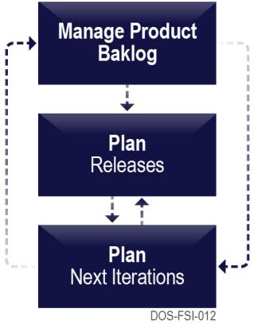

Agile project planning focuses on the planning of the next iteration. After each iteration the project team meets to identify the content (scope) of the next iteration (iteration backlog). At the beginning of the meeting the team verifies that there is agreement on the product backlog and the priority of the listed features. Reprioritization will happen if needed, for example, when the team is unclear with the current order of features listed in the product backlog (step 1 in Figure 2-3). After getting more detail on the features from the customer (if needed), the development team chooses features from the product backlog they think can be accomplished within the next iteration (step 2). In step 3 the team identifies the tasks (user stories) required to implement the chosen features, identifies initial task sequencing, assigns task owners, and estimates tasks (time). During step 3 the team might discover that the effort to complete the chosen features is more or less than the time allotted for the iteration. As a result, features might be removed or added to the iteration backlog (step 4). When functionality is moved back to the product backlog, it can lead to a reprioritization of the product backlog.

Team Patriot fully embraces Agile as our primary method for software development with the full backing of executive leadership. We developed our own scalable Agile DevOps framework based on industry best practices and our collective experience on highly productive Agile programs. On our DOC OCIO MBDA program, we have scaled our Agile practices to support multi-team, multi- project development environments, similar to OCIO. Our approach includes DevSecOps, representing a refinement of DevOps, highlighting the security aspect. It breaks down barriers by providing an operations and security conscious software development paradigm that fuses development, operations, and security into a streamlined process. Our teams consistently achieve on-time, on- budget, full-scope deliveries. Figure: Patriot DevSecOps Approach (refinement of DevOps depicted in Section) demonstrates our overall approach for supporting Agile development and deployment for OCIO. The following sections describe our Agile DevOps approach in accordance with the PWS tasks.

Our Agile DevOps team roles include: 1) architects who interface with the OCIO approved Architecture and Design team to implement and adapt compliant system architectures based on proven system design principles, industry best practices and knowledge of modern software; 2) Scrum Masters who ensure the proper implementation and execution of Agile processes as established by the Processes and Practices team; 3) software developers and subject matter experts who maintain expertise in relevant technologies including Acquia continuous integration and continuous deployment (CI/CD) toolsets, and deployment; 4) systems engineers who effectively derive requirements and translate business needs into user stories for the product backlog; and 5) test engineers holding Section 508 certification and expertise in automated testing tools and methods. We continue to invest in the training and development of our staff through monthly company-sponsored Agile webinars and training courses in emergent technologies. This maximizes team productivity and Agile velocity and ensures integration of modern technologies into OCIO’s solutions.

## 4.1 Task 1 – Application Development Services for CMS

As part of the current team maintaining the OCIO websites , no one is better equipped to come up with a approach and effort that takes to do the development, maintenance, enhancement, migration, and operation of all the websites. After careful analysis of the SOW this is what we propose.

Team Patriot has broad experience integrating Drupal for a wide variety of Department of Commerce systems such as Commerce.gov, MBDA.gov and other Agency systems like GSA.gov, USA.gov, Acquisition.gov etc. This experience, combined with our knowledge of Drupal architecture and ecosystem of community-supported plugins, enables us to efficiently build new systems and add services to existing applications without adding risk to budget or schedule.

Our experienced team who are actively involved with developing and maintaining some of the best sites in federal government will be tasked to come up with the best solutions for the new OCIO website. We will perform architecture and design of the new website using industry best practices. Our team of technical experts and business analysts not only evaluate emerging technologies, but also analyze business needs of the unique and changing Federal market. We try to proactively meet evolving customer needs with innovative solutions. We collaborate with industry vendors and partners, and attend meet-ups and conferences to stay current on industry best practices in responsive mobile design, data analytics and visualization, and enterprise architecture.

We will Develop, Enhance, Modernize, Operate, and Maintain the OCIO website in accordance with Mandates, Policy, and Information System Security. We will implement a complete program to ensure security and policy objectives are met. Our approach to supporting DOC’s system security certification and accreditation follows the security standards throughout the entire system security lifecycle. This activity includes assessing the system security requirements, selecting and designing the appropriate security controls to protect the information, and comprehensively implementing the security controls across the entire system.

Team Patriot will follow an agile development practice which will consist of Dev, QA, UAT and Production cycles. All major and minor changes will be available for the OCIO team to review before it is deployed to production.

The identified and approved components and content of the current OCIO website will be migrated using the Drupal installation profile. We plan to create a robust and generalized framework for OCIO website migration so it will be completed efficiently in the least amount of time with no disruptions. The following steps below will provide a detailed overview of our exact migration strategy.

Our experienced UI/UX designer/themer uses next generation tools to design wireframes, design mockups and deliver high quality website matching the high-quality mockups pixel by pixel. Our UI/UX designer and developer work together to take the site from concept to delivery. Our themer uses Drupal’s templating engine and layout builder to create beautiful templates and layouts which can be used and applied to any content in the site as the site manager wants. This approach in designing the site will give the site manager the freedom to edit specific content portions or sections or the entire page.

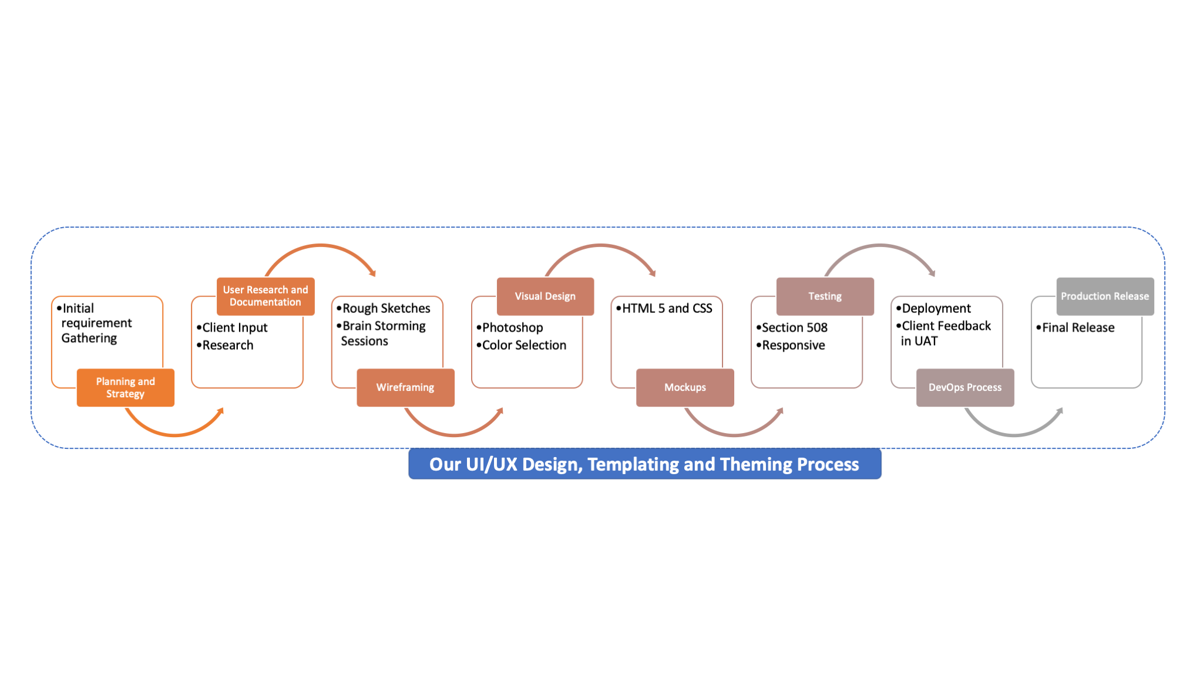.

As explained in the above diagram we have a dedicated process of finalizing and deploying not only templates, and layouts for our web applications but also for webforms, workflows and designs. Team Patriot will make sure to follow the above process for designing, maintaining and deploying any templates, forms and workflows. The above figure describes our comprehensive UI/UX approach and process related to templating and designing components of the website.

We will develop and implement responsive design for the site to accommodate the various mobile form factors as well as touch interactivity. We will expand the use of JQuery and JQueryUI, and update the Drupal theme to use Twitter bootstrap to encourage user responsive behavior.

We follow U.S. Web Design System (USWDS 2.0)—a library of code, tools, and guidance designed to help federal agencies teams build fast, accessible, mobile-friendly websites. USWDS 2.0 is adaptable with improved aesthetics and UX. This includes expressive theming to customize while remaining consistent with the system’s best practice guidance.

Team Patriot will bring a user-centric design and implementation approach to OCIO website’s operations and enhancements. To help improve navigation, search, and ease of use, the team will conduct formalized usability testing in each major release, incorporate results of the testing in design, and ensure continued compliance to accessibility standards. We will do usability testing and utilize advanced techniques such as recorded test sessions and Google analytics mining to track the user’s behavior when interacting with OCIO website. Analyzing the collected data will help the design team determine the usability impact of changes to the site. The designer will produce alternate designs, refined interactions, and additional user guidance to improve user experience and adoption.

Team Patriot has been involved currently on several Drupal migration projects for several agencies and have a strong experience in designing the migration strategies for websites in multiple different technology stacks to drupal.

The following strategy is the culmination of our strategy which has been continually improved over multiple website migrations:

1. Analyze all features of current OCIO website.
2. Generalize features common to all pages and subpages. Generalize the Drupal 9 modules and views that will be common
3. Collect requirements about creating custom modules or views that needs to be created.
4. Create a Generic Drupal 9 theme
5. Provide Interface to configure theme as allowed by OCIO website adhering to standard guidelines
6. Analyze Source Data for OCIO current website
7. Configure Content Types
8. Configure Taxonomy Terms
9. Configure Views and other display reqs
10. Create Images and other design elements unique to site
11. Configure Home page and other configurations as needed
12. Hosting activities. Set up web server, database server and search setup for QA, Staging and Production.
13. Data Migration through generic scripts
14. Data Validation
15. Site testing with the newly populated data set
16. Search Indexing and Search Configuration
17. Search feature and data download testing
18. Staging Site Release
19. User Acceptance Testing
20. Documentation of Steps and Findings
21. Production Release

Below image provides a summary of our migration approach.

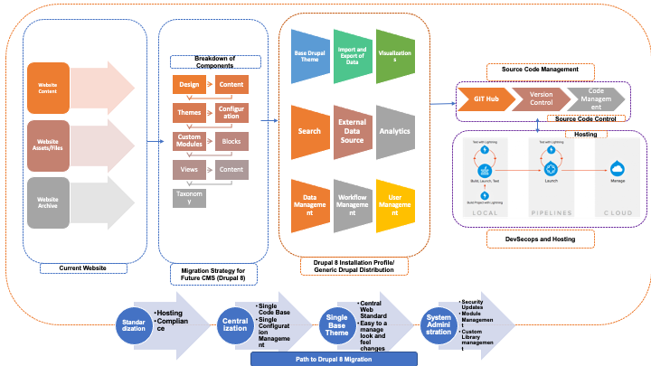

## 

## 4.9 Task 9 – System Administration - DevSecOps Engineering

Team Patriot’s goal with the OCIO website hosting project delivery has three steps:

Reduced burden of deployments with DevSecOps model for Operations and Maintenance of new website post-release and DM&E.

Our technical approach refers to the framework we use to structure, plan, and control the process of developing the new OCIO website and managing the Operation and Maintenance (O&M) phase with implementation of Agile DevSecOps. A variety of such frameworks have evolved over the years, each with its own recognized strengths and weaknesses. We have a hybrid approach to meet today’s government need for faster, cost effective, and secure solutions. We have used several methodologies like Waterfall, Prototyping, Incremental, Spiral, Rapid Application Development, and now Agile/Scrum hybrid to meet our customer needs. Using DevSecOps model to meet the ever-increasing rapid development needs with ease of auto-code deployment and collaboration, we successfully support 25 plus systems using latest in – house and hybrid cloud Software as a Service (SaaS), Platform as a Service (PaaS) and Infrastructure as a Service (IaaS). The technical platforms cover a wide variety and range of technologies and Content Managemernt Systems (CMS) like SalesForce, Drupal(6,7 and 8), Joomla, Wordpress, Asp.net, Sharepoint, Stellent, Dreamweaver, PHP, .Net, Java, HTML5, etc. for our government customers including Department of Commerce (DOC), Environment Protection Agency (EPA), General Services Administration (GSA), Department of Education (ED), with new Development, Modernization, Enhancements (DM&E) including O&M phase.

## Team Patriot Microsoft Azure Agile DevSecOps

* Team Patriot has developed, tested and implemented ready to use Agile DevSecOps environment for Development team on Day 1! of our support for OCIO website hosting service project.

Team Patriot’s DevSecOps solution integrates development and operations into a single- minded entity with common goals: Reliable high-quality software, increased all around Security posture, increased collaboration, faster and easy releases, and improved customer satisfaction. Key Practices developed by

Patriot Center of Excellence (COE) have helped organizations/government agencies innovate faster through automating and streamlining the software development and infrastructure management processes. Most of these practices are accomplished with proper tooling.In our Agile DevSecOps approach depicted in **Figure 1**, there are four main practices and series of tools in each practice area: Agile Development, Continuous Integration, Continuous Testing, and Continuous Delivery. These four practices have Continuous Feedback (CF) and Continuous Service Improvements (CSI) with metrics so we can continue to improve and fine tune to get the desired results for our customers. At OCIO, our objective is to apply these COE key practices to build an increased Security bandwidth website that is primarily reliable and easy to navigate, search, and manage along with other attributes.

**Continuous Integration:** Continuous integration is a software development practice where developers regularly merge their code changes into a central repository, after which automated builds and tests are run. The key goals of continuous integration are to find and address bugs quicker, improve software quality, and reduce the time it takes to validate and release new software updates. Continuous Integration provides these benefits to OCIO:

* Implement **version control** (Git, Bitbucket, SVN, etc).
* **Write tests** for the critical components in OCIO code base (and treat tests as production code)
* Obtain suitable **continuous integration and delivery service** that will enable OCIO to run those tests on every push to the repository and also deploy builds as needed.

**Continuous Delivery:** Continuous practice where software development code changes are automatically built, tested, and prepared for a release to production. It expands upon **Continuous Integration** by deploying all code changes to a testing environment and/or a production environment after the build stage. When continuous delivery is implemented properly, developers will always have a deployment-ready build artifact that has passed through a standardized test process. The microservices architecture is a design approach to build a single application as a set of small services. Each service runs in its own process and communicates with other services through a well-defined interface using a lightweight mechanism, typically an HTTP-based application programming interface (API). Microservices are built around business capabilities; each service is scoped to a single purpose. You can use different frameworks or programming languages to write microservices and deploy them independently, as a single service, or as a group of services.

Continuous Delivery provides these benefits to OCIO:

* Deliver software with fewer bugs and lower risk
* Release new features to OCIO more frequently
* Respond to OCIO change conditions more quickly
* Continuous delivery also takes a lot of stress out of software release; releasing smaller changes more often gets everyone used to a regular, predictable pace

**Continuous Testing:** As DevOps encourages a high level of coordination among various teams in the development value chain, at times, it erases the boundaries of various roles. It requires everyone to contribute across the value chain when needed. Therefore, a developer can configure deployments, QA engineers can configure automation test cases, and deployment engineers can add test cases to the QA repository**.** Together, all are responsible for the quality, and must adhere to the timelines of all deliverables. Patriot follows four quadrants of Agile testing, as depicted in **Figure 2-2**. Continuous Testing, when implemented diligently, allows flawless continuity in the delivery cycle. Integrating a fully automated Continuous Testing process into the Service Development Life Cycle (SDLC) is the most effective solution for a successful Continuous Delivery process. Team Patriot, as an early adopter of agile methodologies and DevOps, can help with OCIO automated testing needs, accomplishing delivery schedules, and bolstering your agile development processes. Continuous Testing provides the following benefits to OCIO:

* Software testing methodology which focuses on achieving continuous quality & improvement
* Continuous testing process helps find risk, address them, and improve quality of the product

Figure 2-2: Four Quadrants of Agile Testing

* Accelerate software delivery - Software release may be weekly to hourly
* Dissolves disconnect between development, testing, and operations teams
* Test Automation helps to achieve consistency by maintaining the same configuration for all relevant tests
* Emphasizes business expectations to mitigate business risks

Before the start of an Agile project we identify a project vision, product roadmap, and a business case. The Agile project life cycle starts with a pre-planning step. This includes collecting and prioritizing business and technical requirements (the product backlog), team formation, and high- level time and cost estimation. The product backlog contains all requirements needed to deliver the final product, system, or service. It is collected from various sources and then prioritized. The team and experts meet and provide high-level estimates using techniques like T-shirt sizing, Planning Poker for each feature/user stories, which include the time it takes to perform all requisite architecture, development, and release activities. Based on these estimates, a first rough estimate for the entire project duration (time), as well as for the overall cost for the realization of the backlog (scope), can be determined. Estimating is an iterative process. In this step the team also chooses the duration of the iterations, if it has not been decided by the organization upfront.

The next step is the IT planning of releases and iterations (**Figure 2-3**). Team Patriot’s agile team will release each iteration to the OCIO when it becomes available or release a collection of iterations at once in one defined release. Release planning will be done either right after the creation of the product backlog or after the first iterations have been completed.

**Release Planning** During release planning our PM’s, government PO, and other stakeholders break the functionality in the product backlog into a number of iterations, ensuring that each iteration can be completed within the duration of iteration. They then assign iterations to releases (release backlog). Every release delivers a working product increment. Based on this release plan, the dates for the release milestones, as well as for the final product release, can be identified (time). The overall project cost will be determined from the labor cost of the Agile team and the number of identified iterations.

Figure 2-3: Inputs, Tools and Techniques, and Outputs for “Plan Releases” process



Agile project planning focuses on the planning of the next iteration. After each iteration the project team meets to identify the content (scope) of the next iteration (iteration backlog). At the beginning of the meeting the team verifies that there is agreement on the product backlog and the priority of the listed features. Reprioritization will happen if needed, for example, when the team is unclear with the current order of features listed in the product backlog (step 1 in Figure 2-3). After getting more detail on the features from the customer (if needed), the development team chooses features from the product backlog they think can be accomplished within the next iteration (step 2). In step 3 the team identifies the tasks (user stories) required to implement the chosen features, identifies initial task sequencing, assigns task owners, and estimates tasks (time). During step 3 the team might discover that the effort to complete the chosen features is more or less than the time allotted for the iteration. As a result, features might be removed or added to the iteration backlog (step 4). When functionality is moved back to the product backlog, it can lead to a reprioritization of the product backlog.

Team Patriot fully embraces Agile as our primary method for software development with the full backing of executive leadership. We developed our own scalable Agile DevOps framework based on industry best practices and our collective experience on highly productive Agile programs. On our DOC OCIO MBDA program, we have scaled our Agile practices to support multi-team, multi- project development environments, similar to OCIO. Our approach includes DevSecOps, representing a refinement of DevOps, highlighting the security aspect. It breaks down barriers by providing an operations and security conscious software development paradigm that fuses development, operations, and security into a streamlined process. Our teams consistently achieve on-time, on- budget, full-scope deliveries. Figure: Patriot DevSecOps Approach (refinement of DevOps depicted in Section) demonstrates our overall approach for supporting Agile development and deployment for OCIO. The following sections describe our Agile DevOps approach in accordance with the PWS tasks.

Our Agile DevOps team roles include: 1) architects who interface with the OCIO approved Architecture and Design team to implement and adapt compliant system architectures based on proven system design principles, industry best practices and knowledge of modern software; 2) Scrum Masters who ensure the proper implementation and execution of Agile processes as established by the Processes and Practices team; 3) software developers and subject matter experts who maintain expertise in relevant technologies including Acquia continuous integration and continuous deployment (CI/CD) toolsets, and deployment; 4) systems engineers who effectively derive requirements and translate business needs into user stories for the product backlog; and 5) test engineers holding Section 508 certification and expertise in automated testing tools and methods. We continue to invest in the training and development of our staff through monthly company-sponsored Agile webinars and training courses in emergent technologies. This maximizes team productivity and Agile velocity and ensures integration of modern technologies into OCIO’s solutions.

**Migration Strategy:**

One thing to remember here is although we are doing iCare migration our work already is based on a generalized strategy, which is common to all Department of Education sites. Before we start the work we have already analyzed all features, datasets and design requirements for the sites to create a common generic platform. The following strategy is the culmination of our strategy for all site Migration and not just one site.

1. Analyze all features of Department of Education sites.
2. Generalize features common to all sites. Generalize the Drupal 9 modules and views that will be common
3. Collect requirements about creating custom modules or views that needs to be created.
4. Create a Generic Drupal 9 theme
5. Provide Interface to configure theme as allowed by Department of Education adhering to standard guidelines
6. Analyze Source Data for All Sites
7. Configure Content Types
8. Configure Taxonomy Terms
9. Configure Views and other display reqs
10. Create Images and other design elements unique to site
11. Configure Home page and other configurations as needed
12. Hosting activities. Set up web server, database server and search setup for QA, Staging and Production.
13. Data Migration through generic scripts
14. Data Validation
15. Site testing with the newly populated data set
16. Search Indexing and Search Configuration
17. Search feature and data download testing
18. Staging Site Release
19. User Acceptance Testing
20. Documentation of Steps and Findings
21. Production Release